SQL Joins

🌟 Definition
# Source: AI Source: Provided by: [Data Path: Persons Table -> ID Column: 1, Name_En Column: Motasem Essam] -> From: [ChatGPT] on [6/11/2026]
SQL Joins are used to combine rows from two or more tables based on a related column.
Joins allow you to retrieve related data that is stored in separate tables, reducing data duplication and supporting relational database design.

🎯 Purpose
# Source: AI Source: Provided by: [Data Path: Persons Table -> ID Column: 1, Name_En Column: Motasem Essam] -> From: [ChatGPT] on [6/11/2026]
SQL Joins are used to:
- Retrieve related data from multiple tables
- Combine information stored in different tables
- Reduce data redundancy
- Build reports using related tables
- Analyze relationships between entities

🧠 Why Do We Need Joins?
# Source: AI Source: Provided by: [Data Path: Persons Table -> ID Column: 1, Name_En Column: Motasem Essam] -> From: [ChatGPT] on [6/11/2026]
In a relational database, data is often divided into multiple tables.
Customers Table
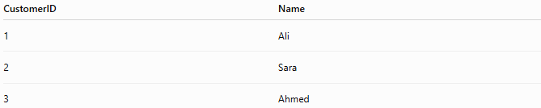
CustomerID | Name
1 | Ali
2 | Sara
3 | Ahmed

Orders Table
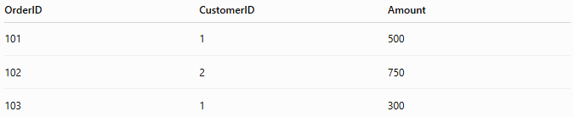
OrderID | CustomerID | Amount
101 | 1 | 500
102 | 2 | 750
103 | 1 | 300
The CustomerID links the two tables.
Using a JOIN, we can display:
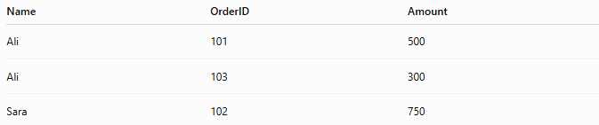
Name | OrderID | Amount
Ali | 101 | 500
Ali | 103 | 300
Sara | 102 | 750

📝 Syntax
# Source: AI Source: Provided by: [Data Path: Persons Table -> ID Column: 1, Name_En Column: Motasem Essam] -> From: [ChatGPT] on [6/11/2026]
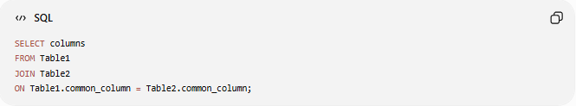
SELECT columns
FROM Table1
JOIN Table2
ON Table1.common_column = Table2.common_column;

🔢 Types of SQL Joins
# Source: AI Source: Provided by: [Data Path: Persons Table -> ID Column: 1, Name_En Column: Motasem Essam] -> From: [ChatGPT] on [6/11/2026]
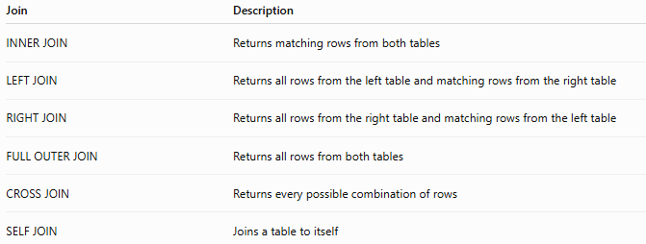
Join | Description
INNER JOIN | Returns matching rows from both tables
LEFT JOIN | Returns all rows from the left table and matching rows from the right table
RIGHT JOIN | Returns all rows from the right table and matching rows from the left table
FULL OUTER JOIN | Returns all rows from both tables
CROSS JOIN | Returns every possible combination of rows
SELF JOIN | Joins a table to itself

📊 Visual Representation
# Source: AI Source: Provided by: [Data Path: Persons Table -> ID Column: 1, Name_En Column: Motasem Essam] -> From: [ChatGPT] on [6/11/2026]
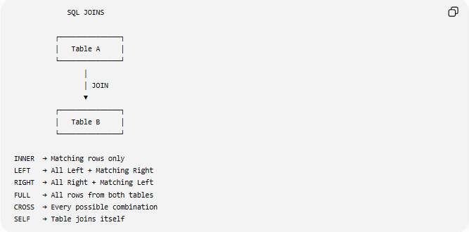
SQL JOINS

┌───────────────┐
│ Table A │
└───────────────┘
│
│ JOIN
▼
┌───────────────┐
│ Table B │
└───────────────┘

INNER → Matching rows only
LEFT → All Left + Matching Right
RIGHT → All Right + Matching Left
FULL → All rows from both tables
CROSS → Every possible combination
SELF → Table joins itself

🛠️ Sample Tables
# Source: AI Source: Provided by: [Data Path: Persons Table -> ID Column: 1, Name_En Column: Motasem Essam] -> From: [ChatGPT] on [6/11/2026]
Customers
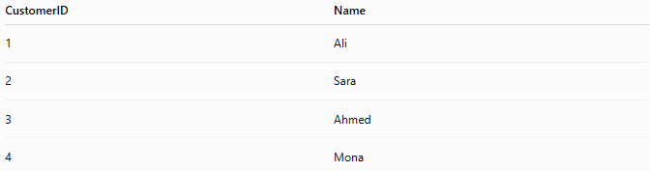
CustomerID | Name
1 | Ali
2 | Sara
3 | Ahmed
4 | Mona

Orders
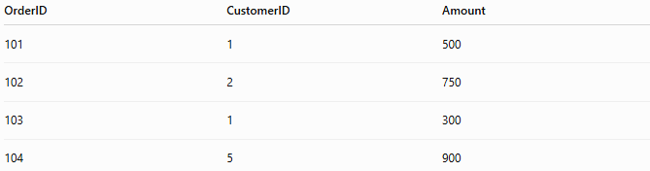
OrderID | CustomerID | Amount
101 | 1 | 500
102 | 2 | 750
103 | 1 | 300
104 | 5 | 900

1️⃣ INNER JOIN
# Source: AI Source: Provided by: [Data Path: Persons Table -> ID Column: 1, Name_En Column: Motasem Essam] -> From: [ChatGPT] on [6/11/2026]
Returns only rows with matching values in both tables.
Syntax
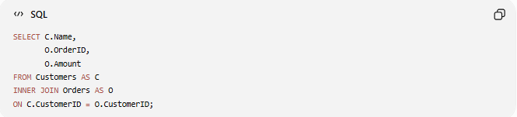
SELECT C.Name,
O.OrderID,
O.Amount
FROM Customers AS C
INNER JOIN Orders AS O
ON C.CustomerID = O.CustomerID;

Result
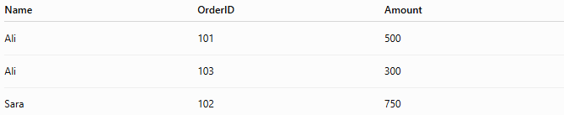
Name | OrderID | Amount
Ali | 101 | 500
Ali | 103 | 300
Sara | 102 | 750
Only matching records are returned.

2️⃣ LEFT JOIN
# Source: AI Source: Provided by: [Data Path: Persons Table -> ID Column: 1, Name_En Column: Motasem Essam] -> From: [ChatGPT] on [6/11/2026]
Returns all rows from the left table and matching rows from the right table.
If there is no match, NULL values are returned.
Example
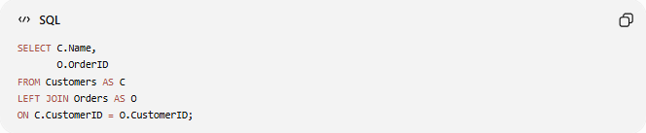
SELECT C.Name,
O.OrderID
FROM Customers AS C
LEFT JOIN Orders AS O
ON C.CustomerID = O.CustomerID;

Result
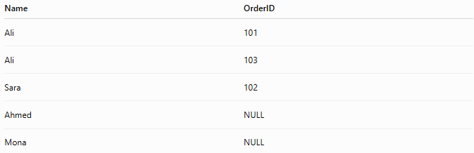
Name | OrderID
Ali | 101
Ali | 103
Sara | 102
Ahmed | NULL
Mona | NULL

3️⃣ RIGHT JOIN
# Source: AI Source: Provided by: [Data Path: Persons Table -> ID Column: 1, Name_En Column: Motasem Essam] -> From: [ChatGPT] on [6/11/2026]
Returns all rows from the right table and matching rows from the left table.
Example
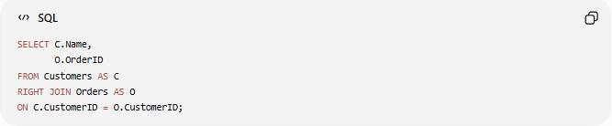
SELECT C.Name,
O.OrderID
FROM Customers AS C
RIGHT JOIN Orders AS O
ON C.CustomerID = O.CustomerID;

Result
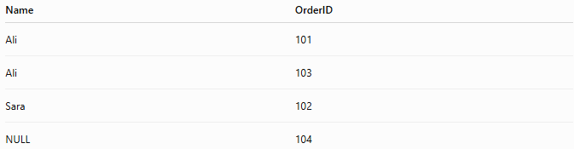
Name | OrderID
Ali | 101
Ali | 103
Sara | 102
NULL | 104
Order 104 has no matching customer.

4️⃣ FULL OUTER JOIN
# Source: AI Source: Provided by: [Data Path: Persons Table -> ID Column: 1, Name_En Column: Motasem Essam] -> From: [ChatGPT] on [6/11/2026]
Returns all rows from both tables.
Rows without matches contain NULL values.
Example
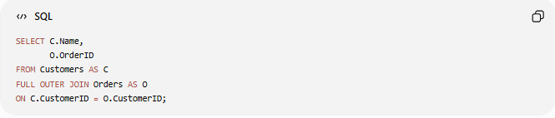
SELECT C.Name,
O.OrderID
FROM Customers AS C
FULL OUTER JOIN Orders AS O
ON C.CustomerID = O.CustomerID;

Result
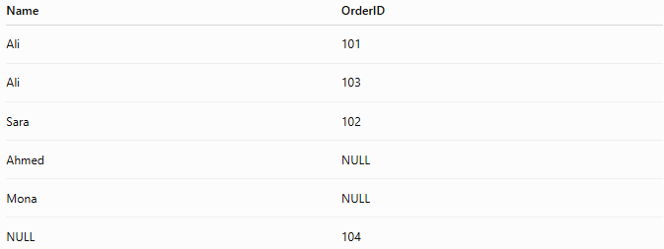
Name | OrderID
Ali | 101
Ali | 103
Sara | 102
Ahmed | NULL
Mona | NULL
NULL | 104

5️⃣ CROSS JOIN
# Source: AI Source: Provided by: [Data Path: Persons Table -> ID Column: 1, Name_En Column: Motasem Essam] -> From: [ChatGPT] on [6/11/2026]
Returns every possible combination of rows.
If one table has 4 rows and another has 3 rows:
4 × 3 = 12 rows
Example
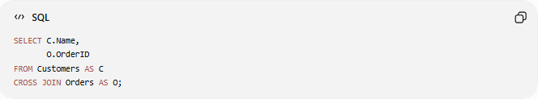
SELECT C.Name,
O.OrderID
FROM Customers AS C
CROSS JOIN Orders AS O;

6️⃣ SELF JOIN
# Source: AI Source: Provided by: [Data Path: Persons Table -> ID Column: 1, Name_En Column: Motasem Essam] -> From: [ChatGPT] on [6/11/2026]
Joins a table with itself.
Useful for:
- Employees and Managers
- Parent and Child records
- Categories and Subcategories
Employees Table
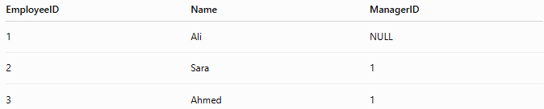
EmployeeID | Name | ManagerID
1 | Ali | NULL
2 | Sara | 1
3 | Ahmed | 1

Example
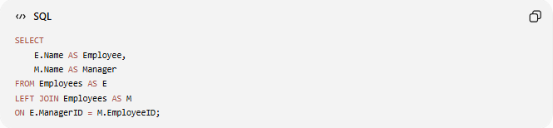
SELECT
E.Name AS Employee,
M.Name AS Manager
FROM Employees AS E
LEFT JOIN Employees AS M
ON E.ManagerID = M.EmployeeID;

Result
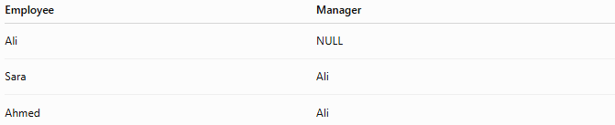
Employee | Manager
Ali | NULL
Sara | Ali
Ahmed | Ali

📊 Join Comparison
# Source: AI Source: Provided by: [Data Path: Persons Table -> ID Column: 1, Name_En Column: Motasem Essam] -> From: [ChatGPT] on [6/11/2026]
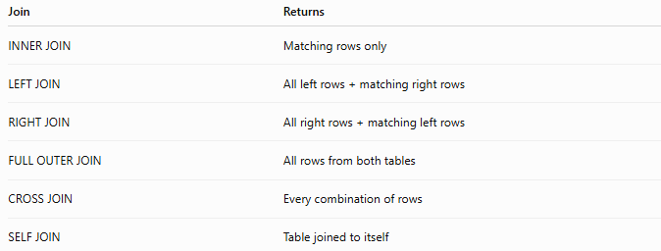
Join | Returns
INNER JOIN | Matching rows only
LEFT JOIN | All left rows + matching right rows
RIGHT JOIN | All right rows + matching left rows
FULL OUTER JOIN | All rows from both tables
CROSS JOIN | Every combination of rows
SELF JOIN | Table joined to itself

🛠️ Complete Test Example

Create Customers
# Source: AI Source: Provided by: [Data Path: Persons Table -> ID Column: 1, Name_En Column: Motasem Essam] -> From: [ChatGPT] on [6/11/2026]
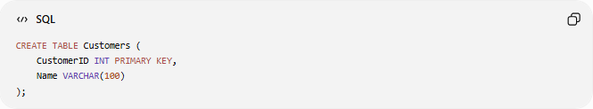
CREATE TABLE Customers (
CustomerID INT PRIMARY KEY,
Name VARCHAR(100)
);

Create Orders
# Source: AI Source: Provided by: [Data Path: Persons Table -> ID Column: 1, Name_En Column: Motasem Essam] -> From: [ChatGPT] on [6/11/2026]
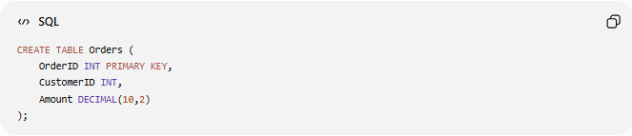
CREATE TABLE Orders (
OrderID INT PRIMARY KEY,
CustomerID INT,
Amount DECIMAL(10,2)
);

Insert Data
# Source: AI Source: Provided by: [Data Path: Persons Table -> ID Column: 1, Name_En Column: Motasem Essam] -> From: [ChatGPT] on [6/11/2026]
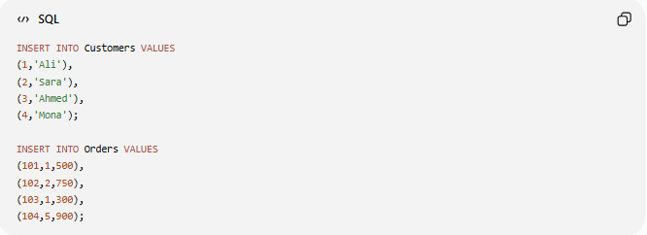
INSERT INTO Customers VALUES
(1,'Ali'),
(2,'Sara'),
(3,'Ahmed'),
(4,'Mona');

INSERT INTO Orders VALUES
(101,1,500),
(102,2,750),
(103,1,300),
(104,5,900);

INNER JOIN
# Source: AI Source: Provided by: [Data Path: Persons Table -> ID Column: 1, Name_En Column: Motasem Essam] -> From: [ChatGPT] on [6/11/2026]
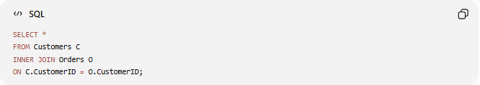
SELECT *
FROM Customers C
INNER JOIN Orders O
ON C.CustomerID = O.CustomerID;

LEFT JOIN
# Source: AI Source: Provided by: [Data Path: Persons Table -> ID Column: 1, Name_En Column: Motasem Essam] -> From: [ChatGPT] on [6/11/2026]
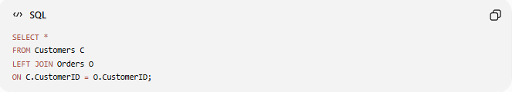
SELECT *
FROM Customers C
LEFT JOIN Orders O
ON C.CustomerID = O.CustomerID;

RIGHT JOIN
# Source: AI Source: Provided by: [Data Path: Persons Table -> ID Column: 1, Name_En Column: Motasem Essam] -> From: [ChatGPT] on [6/11/2026]
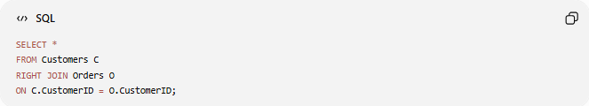
SELECT *
FROM Customers C
RIGHT JOIN Orders O
ON C.CustomerID = O.CustomerID;

CROSS JOIN
# Source: AI Source: Provided by: [Data Path: Persons Table -> ID Column: 1, Name_En Column: Motasem Essam] -> From: [ChatGPT] on [6/11/2026]
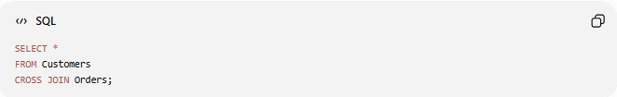
SELECT *
FROM Customers
CROSS JOIN Orders;

Real Example

prepared commands

Create Customers
# Source: ScreenShot Source: Provided by: [Persons Table -> ID Column: 1, Name_En Column: Motasem Essam] -> Tool: [Automation Table -> ID Column: 16, Name_En Column: Screen Capture] -> From [Operating System: Wampserver64 -> phpmyadmin] on [6/11/2026]
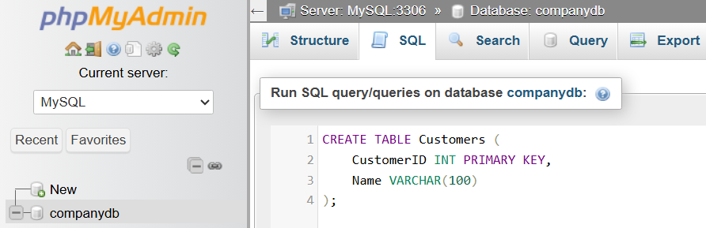
CREATE TABLE Customers (
CustomerID INT PRIMARY KEY,
Name VARCHAR(100)
);
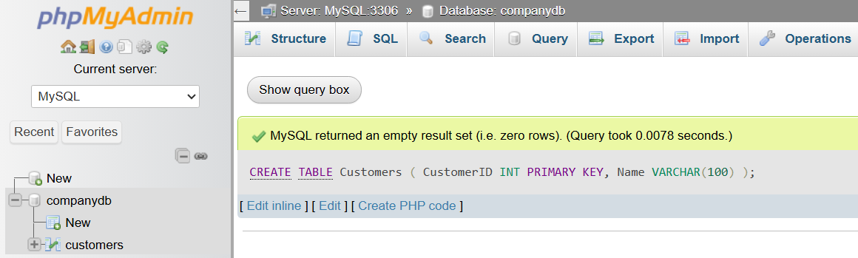

Create Orders
# Source: ScreenShot Source: Provided by: [Persons Table -> ID Column: 1, Name_En Column: Motasem Essam] -> Tool: [Automation Table -> ID Column: 16, Name_En Column: Screen Capture] -> From [Operating System: Wampserver64 -> phpmyadmin] on [6/11/2026]
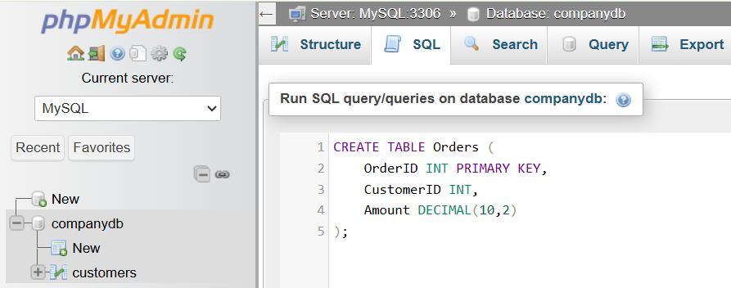
CREATE TABLE Orders (
OrderID INT PRIMARY KEY,
CustomerID INT,
Amount DECIMAL(10,2)
);
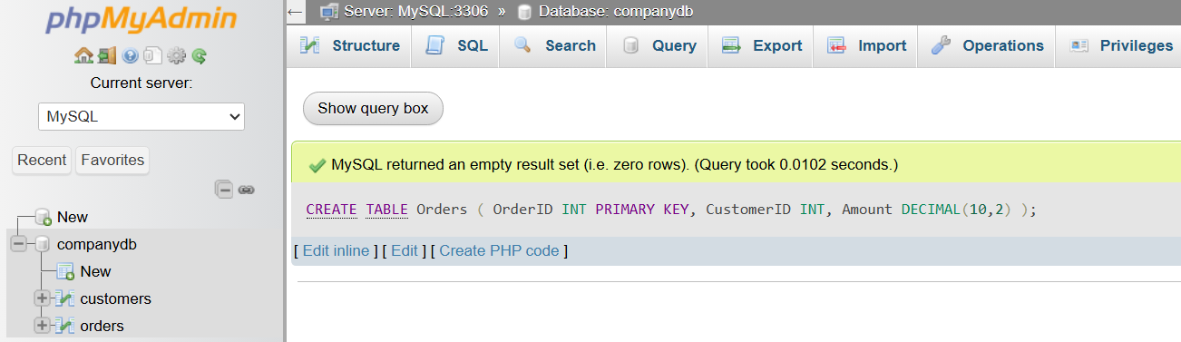

Insert Data
# Source: ScreenShot Source: Provided by: [Persons Table -> ID Column: 1, Name_En Column: Motasem Essam] -> Tool: [Automation Table -> ID Column: 16, Name_En Column: Screen Capture] -> From [Operating System: Wampserver64 -> phpmyadmin] on [6/11/2026]
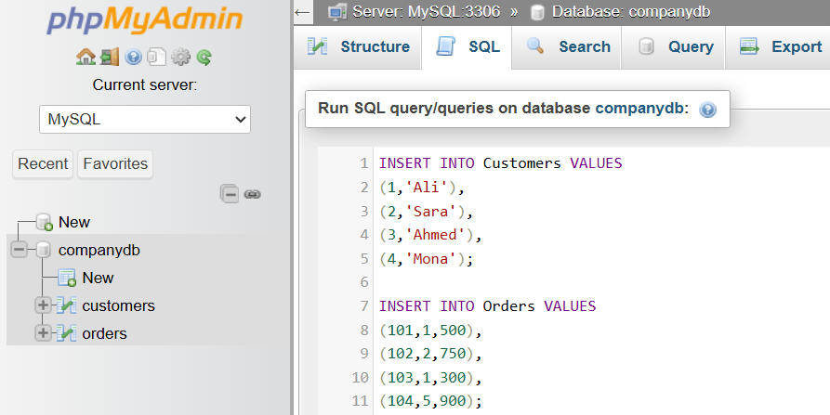
INSERT INTO Customers VALUES
(1,'Ali'),
(2,'Sara'),
(3,'Ahmed'),
(4,'Mona');

INSERT INTO Orders VALUES
(101,1,500),
(102,2,750),
(103,1,300),
(104,5,900);
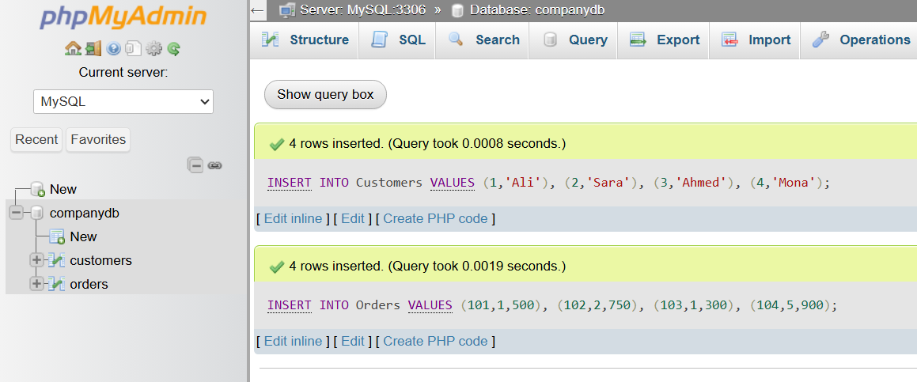

basic command

INNER JOIN
# Source: ScreenShot Source: Provided by: [Persons Table -> ID Column: 1, Name_En Column: Motasem Essam] -> Tool: [Automation Table -> ID Column: 16, Name_En Column: Screen Capture] -> From [Operating System: Wampserver64 -> phpmyadmin] on [6/11/2026]
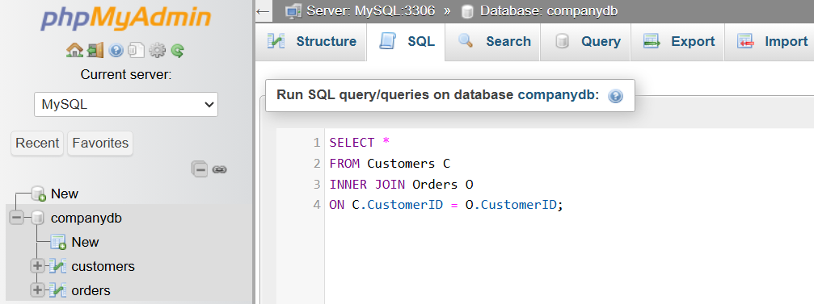
SELECT *
FROM Customers C
INNER JOIN Orders O
ON C.CustomerID = O.CustomerID;
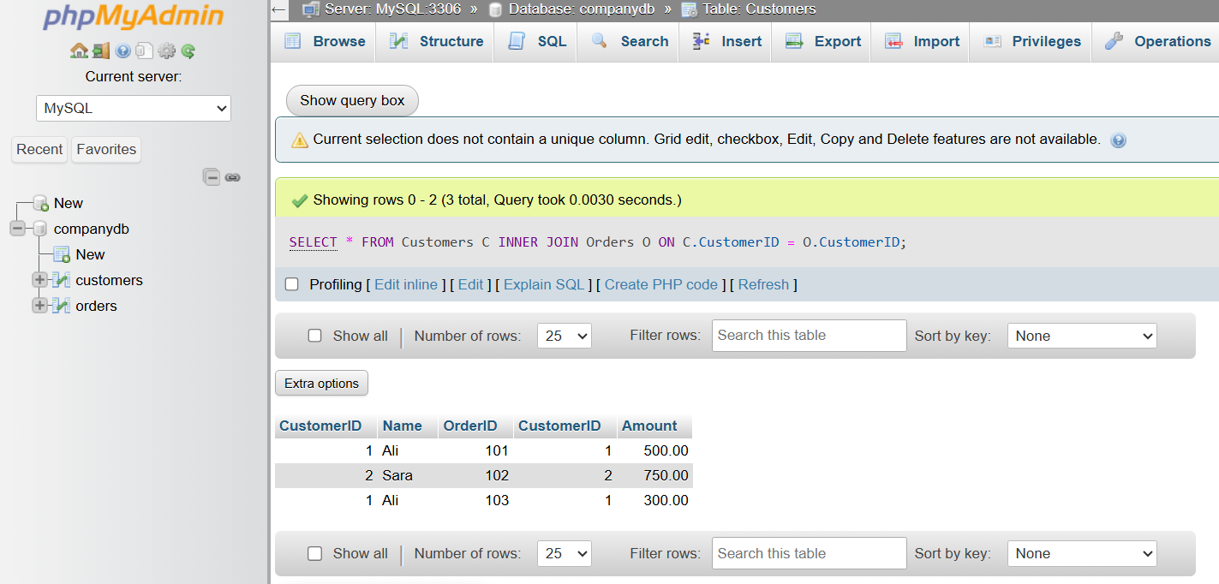

LEFT JOIN
# Source: ScreenShot Source: Provided by: [Persons Table -> ID Column: 1, Name_En Column: Motasem Essam] -> Tool: [Automation Table -> ID Column: 16, Name_En Column: Screen Capture] -> From [Operating System: Wampserver64 -> phpmyadmin] on [6/11/2026]
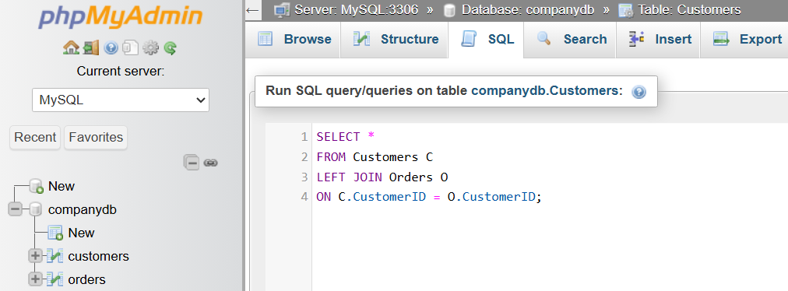
SELECT *
FROM Customers C
LEFT JOIN Orders O
ON C.CustomerID = O.CustomerID;
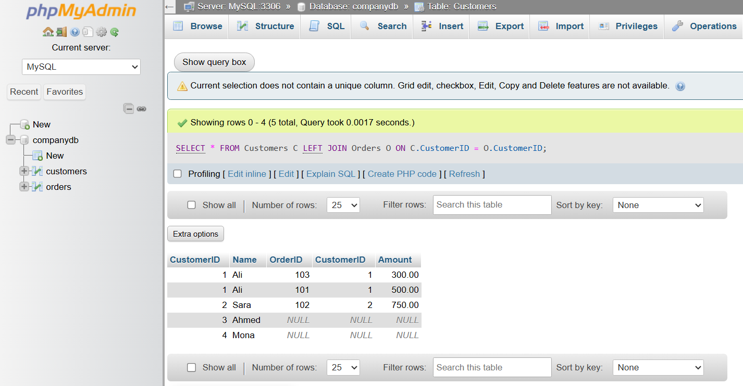

RIGHT JOIN
# Source: ScreenShot Source: Provided by: [Persons Table -> ID Column: 1, Name_En Column: Motasem Essam] -> Tool: [Automation Table -> ID Column: 16, Name_En Column: Screen Capture] -> From [Operating System: Wampserver64 -> phpmyadmin] on [6/11/2026]
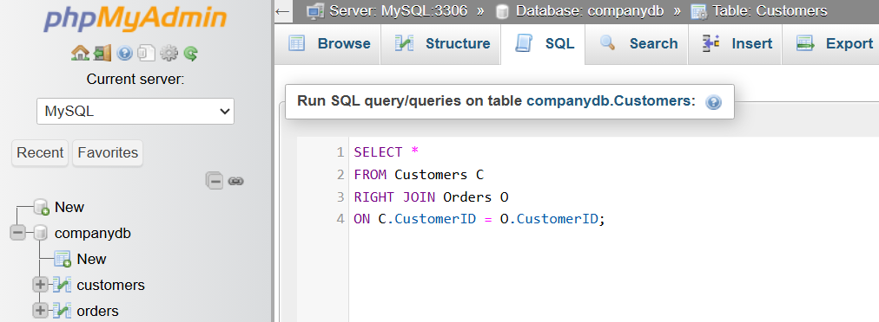
SELECT *
FROM Customers C
RIGHT JOIN Orders O
ON C.CustomerID = O.CustomerID;
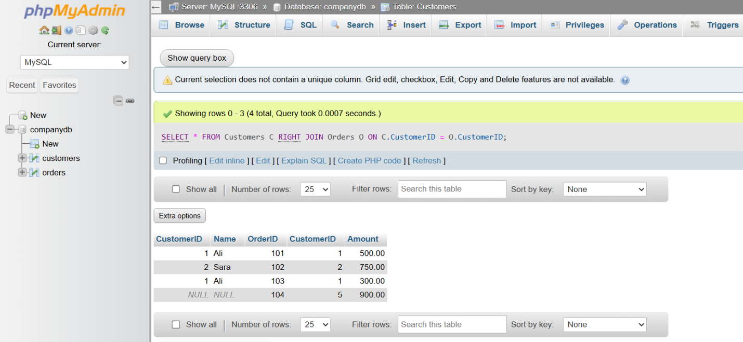

CROSS JOIN
# Source: ScreenShot Source: Provided by: [Persons Table -> ID Column: 1, Name_En Column: Motasem Essam] -> Tool: [Automation Table -> ID Column: 16, Name_En Column: Screen Capture] -> From [Operating System: Wampserver64 -> phpmyadmin] on [6/11/2026]
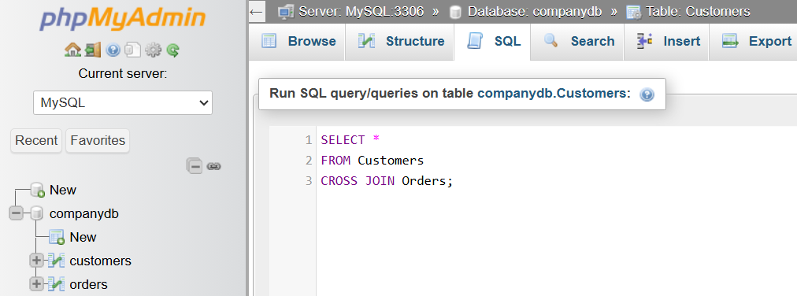
SELECT *
FROM Customers
CROSS JOIN Orders;
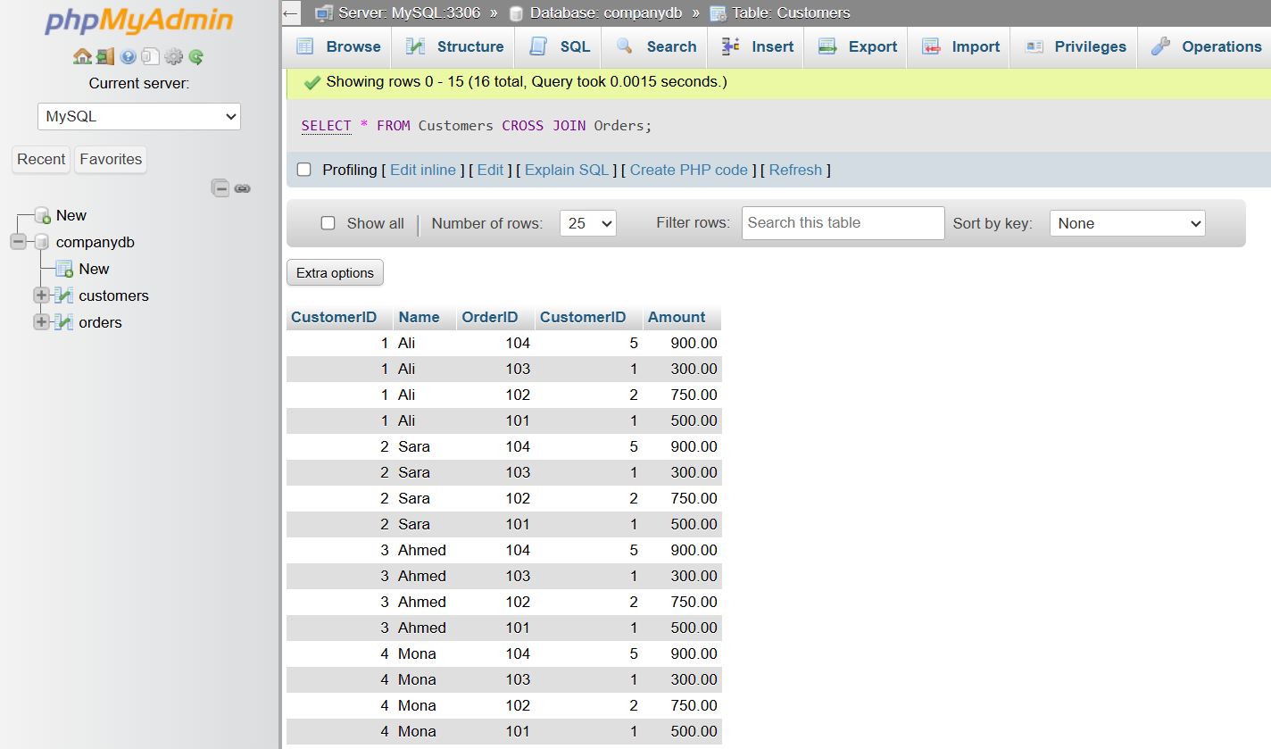

⚠️ Important Notes
# Source: AI Source: Provided by: [Data Path: Persons Table -> ID Column: 1, Name_En Column: Motasem Essam] -> From: [ChatGPT] on [6/11/2026]
- Joins require a related column (usually a Primary Key and Foreign Key).
- INNER JOIN is the most commonly used join.
- LEFT JOIN is useful for finding records with no matching data.
- FULL OUTER JOIN is not supported by MySQL. It can be simulated using UNION.
- CROSS JOIN can produce a very large number of rows.

🌍 Database Support
# Source: AI Source: Provided by: [Data Path: Persons Table -> ID Column: 1, Name_En Column: Motasem Essam] -> From: [ChatGPT] on [6/11/2026]
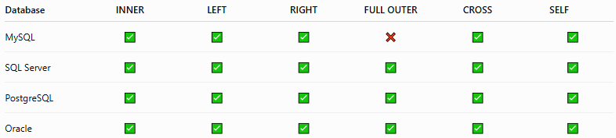
Database | INNER | LEFT | RIGHT | FULL OUTER | CROSS | SELF
MySQL | ✅ | ✅ | ✅ | ❌ | ✅ | ✅
SQL Server | ✅ | ✅ | ✅ | ✅ | ✅ | ✅
PostgreSQL | ✅ | ✅ | ✅ | ✅ | ✅ | ✅
Oracle | ✅ | ✅ | ✅ | ✅ | ✅ | ✅

🔢 SQL Joins Workflow
# Source: AI Source: Provided by: [Data Path: Persons Table -> ID Column: 1, Name_En Column: Motasem Essam] -> From: [ChatGPT] on [6/11/2026]
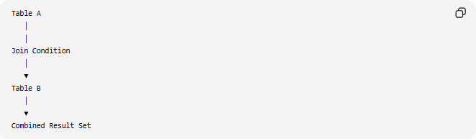
Table A
│
│
Join Condition
│
▼
Table B
│
▼
Combined Result Set

🧠 Simple Analogy
# Source: AI Source: Provided by: [Data Path: Persons Table -> ID Column: 1, Name_En Column: Motasem Essam] -> From: [ChatGPT] on [6/11/2026]
Imagine two lists:
Student List

1 Ali
2 Sara
3 Ahmed
Grade List
1 A
2 B
- INNER JOIN → Students with grades only.
- LEFT JOIN → All students, even if they don't have grades.
- RIGHT JOIN → All grades, even if there is no matching student.
- FULL OUTER JOIN → Everything from both lists.
- CROSS JOIN → Every student paired with every grade.
- SELF JOIN → Compare students within the same list (for example, mentor–student relationships).

🧭 Summary
# Source: AI Source: Provided by: [Data Path: Persons Table -> ID Column: 1, Name_En Column: Motasem Essam] -> From: [ChatGPT] on [6/11/2026]
SQL Joins combine data from two or more related tables using a common column, typically a Primary Key and Foreign Key. The main join types are INNER JOIN, LEFT JOIN, RIGHT JOIN, FULL OUTER JOIN, CROSS JOIN, and SELF JOIN. Joins are fundamental to relational databases because they allow related information stored in separate tables to be retrieved efficiently in a single query.

